**AQUA GOLD **

****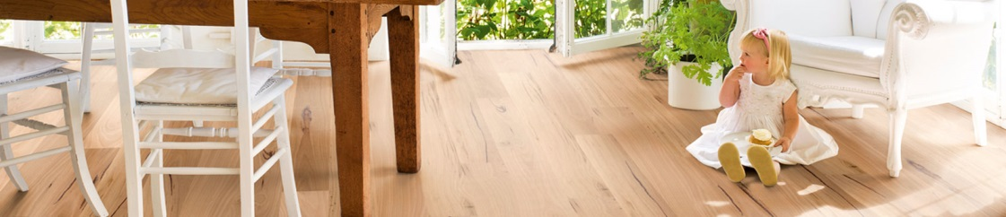

**Maintaining Your AQUA GOLD floor**

Congratulations on your choice of the AQUA GOLD System.

Some basic care instructions that will ensure the longevity of your timber floor.

* Allow the floor to cure for at least 5 days before subjecting it to heavy traffic and furniture placement.
* Any spills should be wiped off the floor when they occur
* Do not use abrasive cleaners, steel wool or scouring powder on your floor
* Install a good quality mat both inside and outside of external doors. Mats should be as large as possible and able to remove both grit and moisture.
* Use high density felt protectors on all furniture legs / bases to prevent damage.
* Whenever possible remove your shoes. This will help reduce the amount of dirt brought into the property

Stilettos have the potential to cause considerable impact damage to a timber floors.

Dog’s claws if not trimmed increase the possibility of scratches and indentations..

Clean the floor regularly using dry cleaning methods. Recommended suitable methods include ideally the **ENJO** chemical free system or soft broom or vacuum with a soft brush attachment. Regular removal of surface dirt and sand will prevent the surface from being scratched.

If an area of the floor begins to look slightly dull in comparison to the remainder the use of AQUA GOLD REVIVE should be considered.

REVIVE is designed to restore an even sheen to the floor whilst giving added protection to the surface against future traffic.

Domestic staircases have a specific requirement for slip resistance and Revive should not be considered for this purpose.

* See application guide for AQUA GOLD REVIVE