**AQUA GOLD**

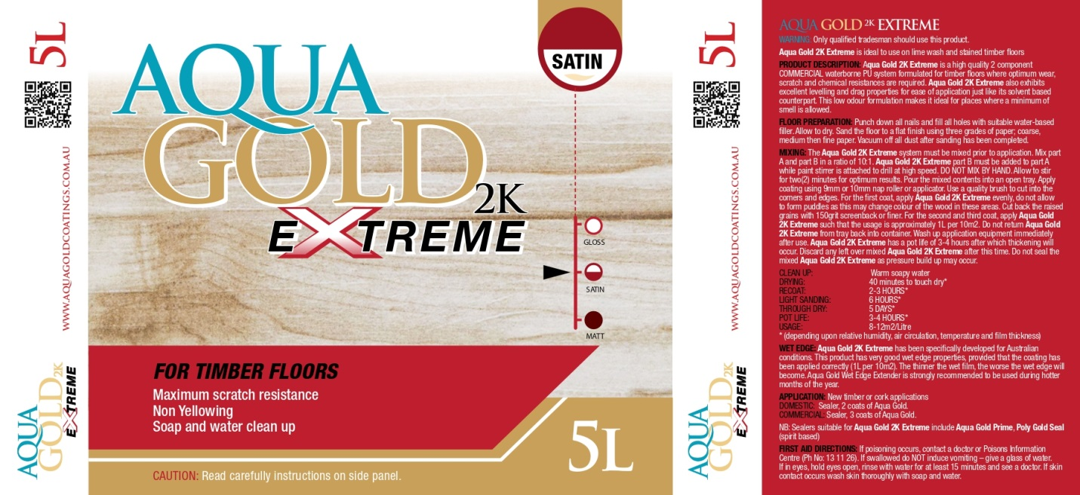

Aqua Gold Extreme

* Two component PU system
* Excellent adhesion
* Extreme scratch, wear and chemical resistances
* Excellent levelling and brush drag properties
* Low VOC formulation
* Hi solids

**TYPICAL PROPERTIES**

Appearance Milky white, translucent

Solids 42%

Density 0.96

Viscosity 150cPs @ 25°C

Volatile Organic Content Wt % 12%

**APPLICATION PROPERTIES**

Recoat time 2-3 hrs @ 25°C

Coverage 10²m/L

Gloss Level 60° Specular Gloss 90, Satin 45, Matt 25

Wash up Water

Full Cure 5-7 days